**Test Automation Project with Selenium and NUnit**

**Overview**

This project demonstrates automated testing of a web application using Selenium with NUnit framework in C#.

**Prerequisites**

* **Visual Studio**: Ensure you have Visual Studio installed to run the project.
* **.NET Framework**: The project targets .NET Framework 8.0.
* **Selenium for .NET**: selenium is used for browser automation. It will be installed as a NuGet package automatically.
* **NUnit Framework**: Tests are organized and executed using NUnit.
* **ExtentReports**: Used for generating HTML reports of test executions.

**Setup Instructions**

1. **Clone Repository**: Clone this repository to your local machine.
2. **Open Project**: Open the solution (PilotProject.sln) in Visual Studio.
3. **Restore Packages**: Restore Nuget packages to ensure all dependencies are installed.
4. **Run Tests**: Execute tests using NUnit Test Explorer in Visual Studio.  
   1:- Click on Test Option in Visual studio  
   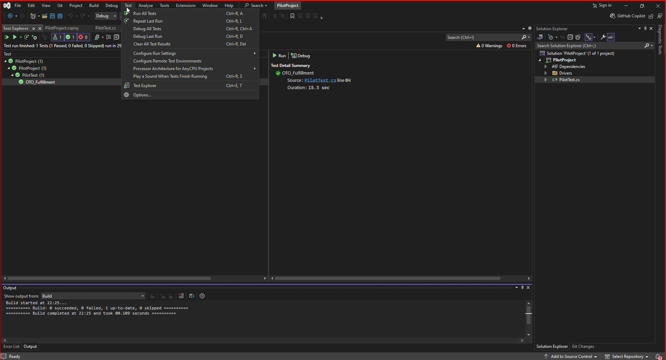  
     
     
     
   2:- Test Explorer Section opened then right click on OTO_FulFillment scenario and then click on Run Option to perform headless execution.

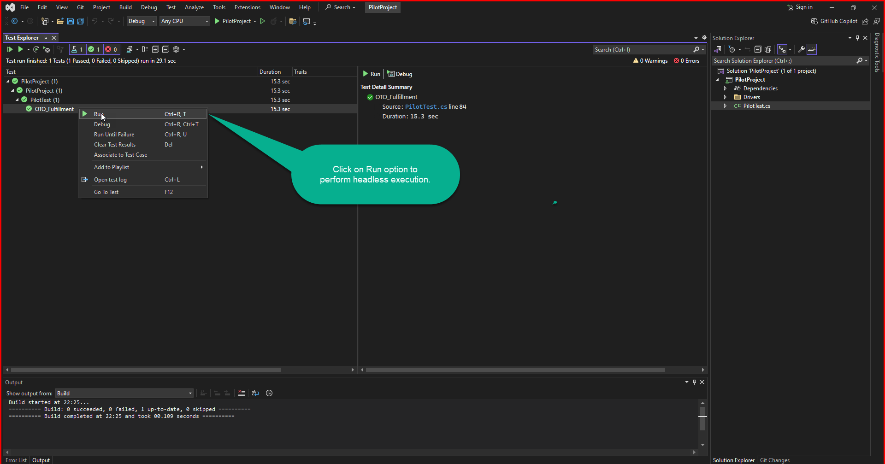

**Reports**

Test execution results are captured in HTML format using Custom Report, providing detailed insights into test outcomes. As tested evidence have shown in below screen shots.

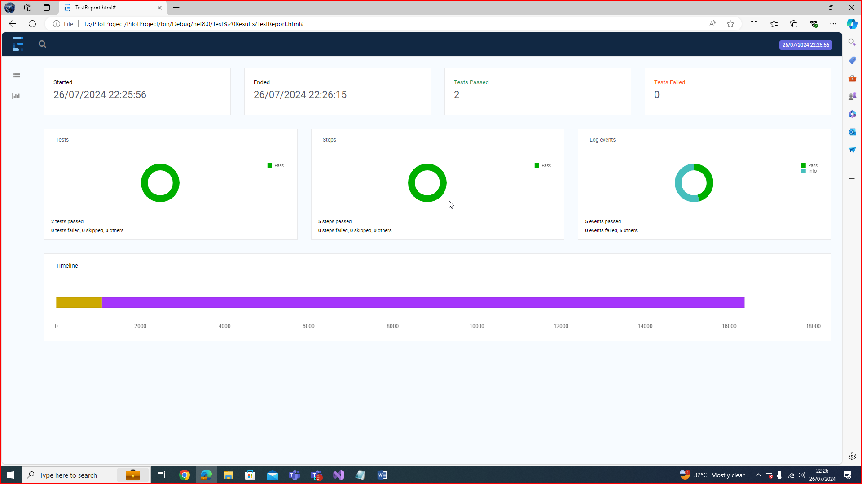

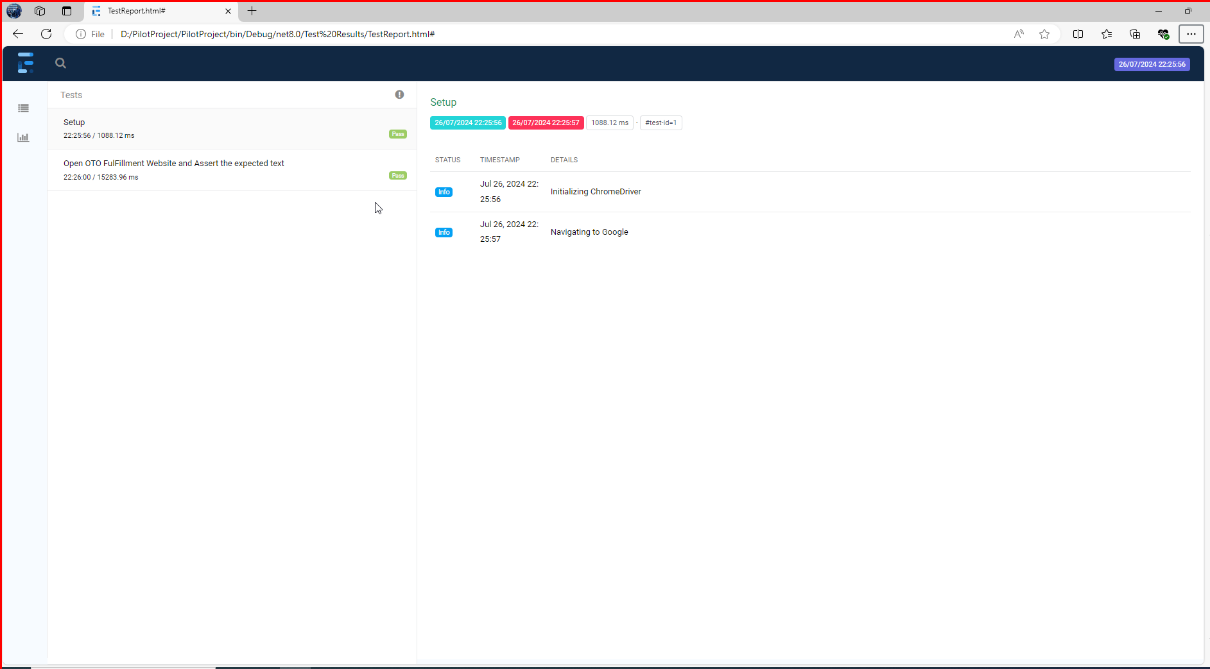

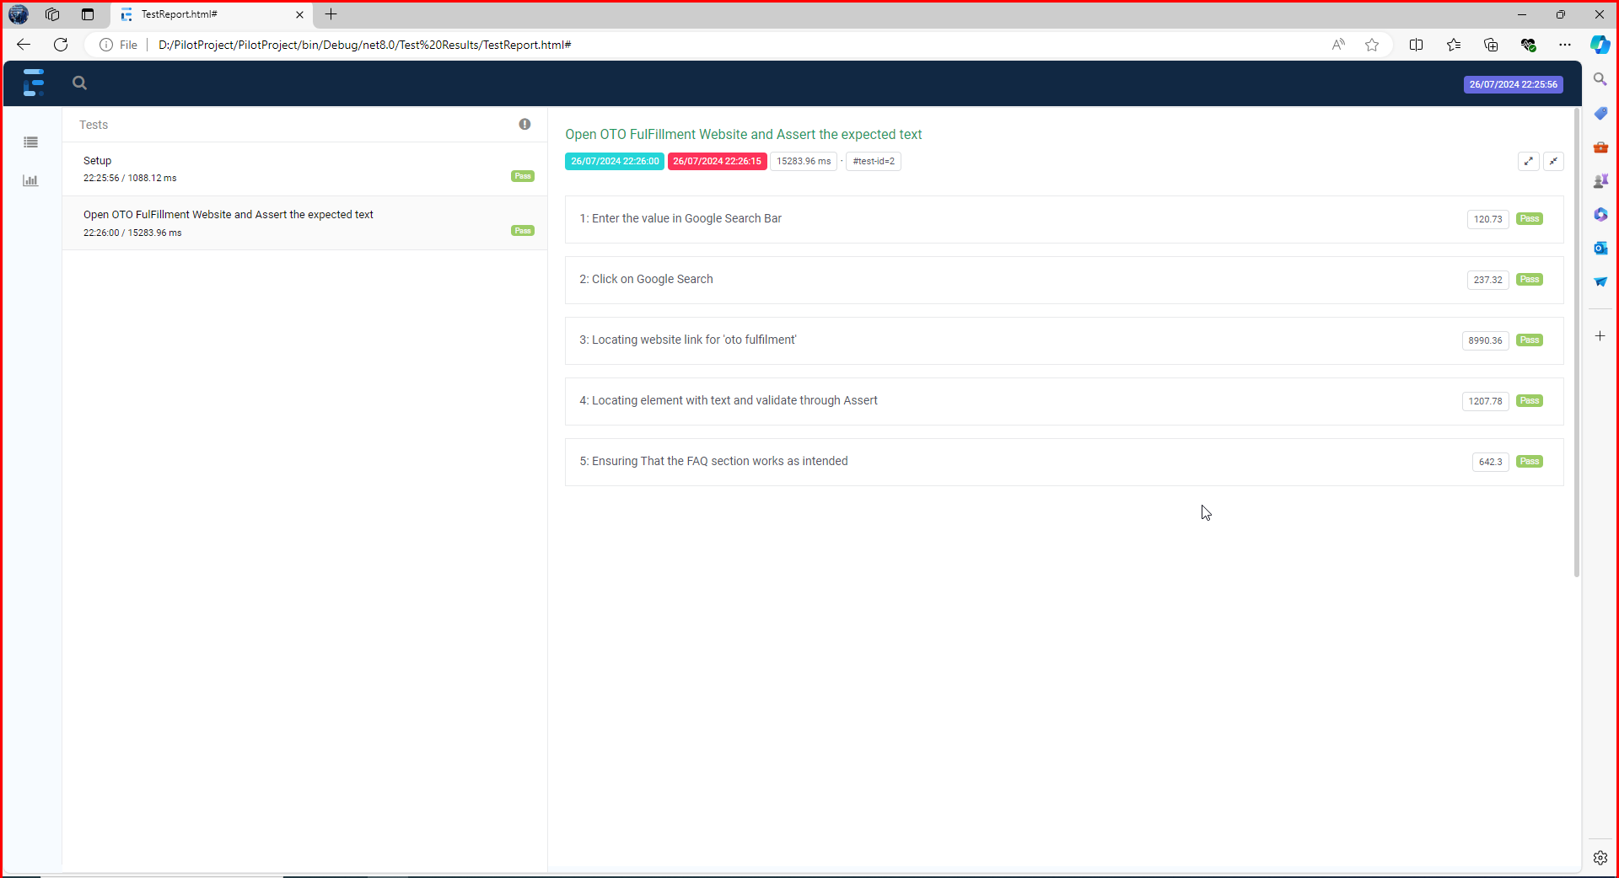

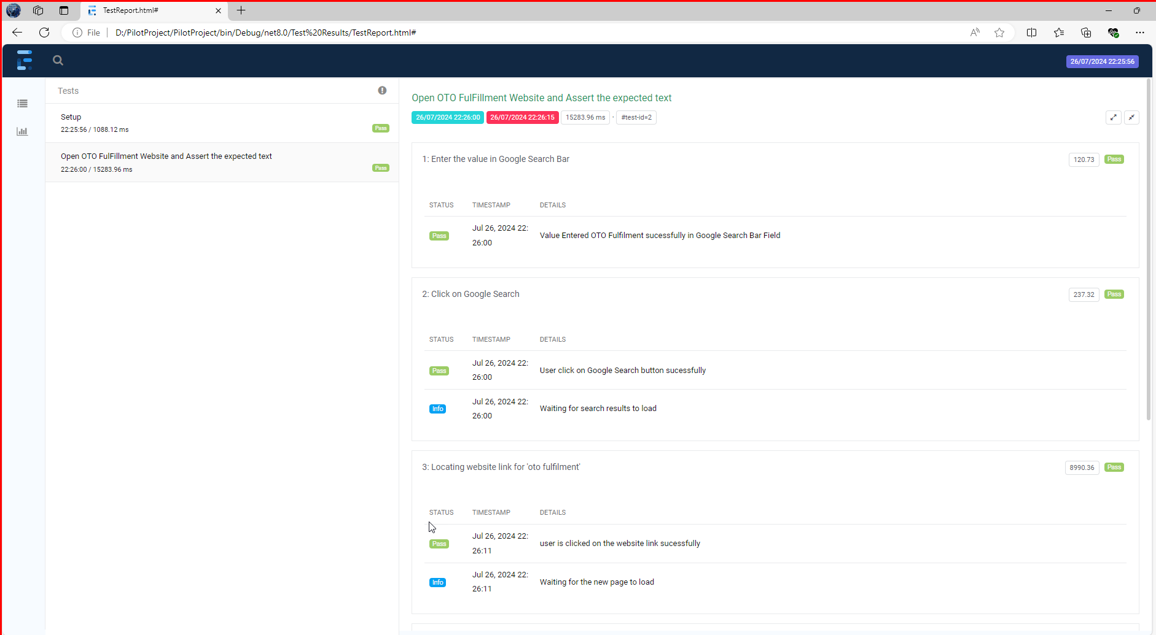  
  
  
  
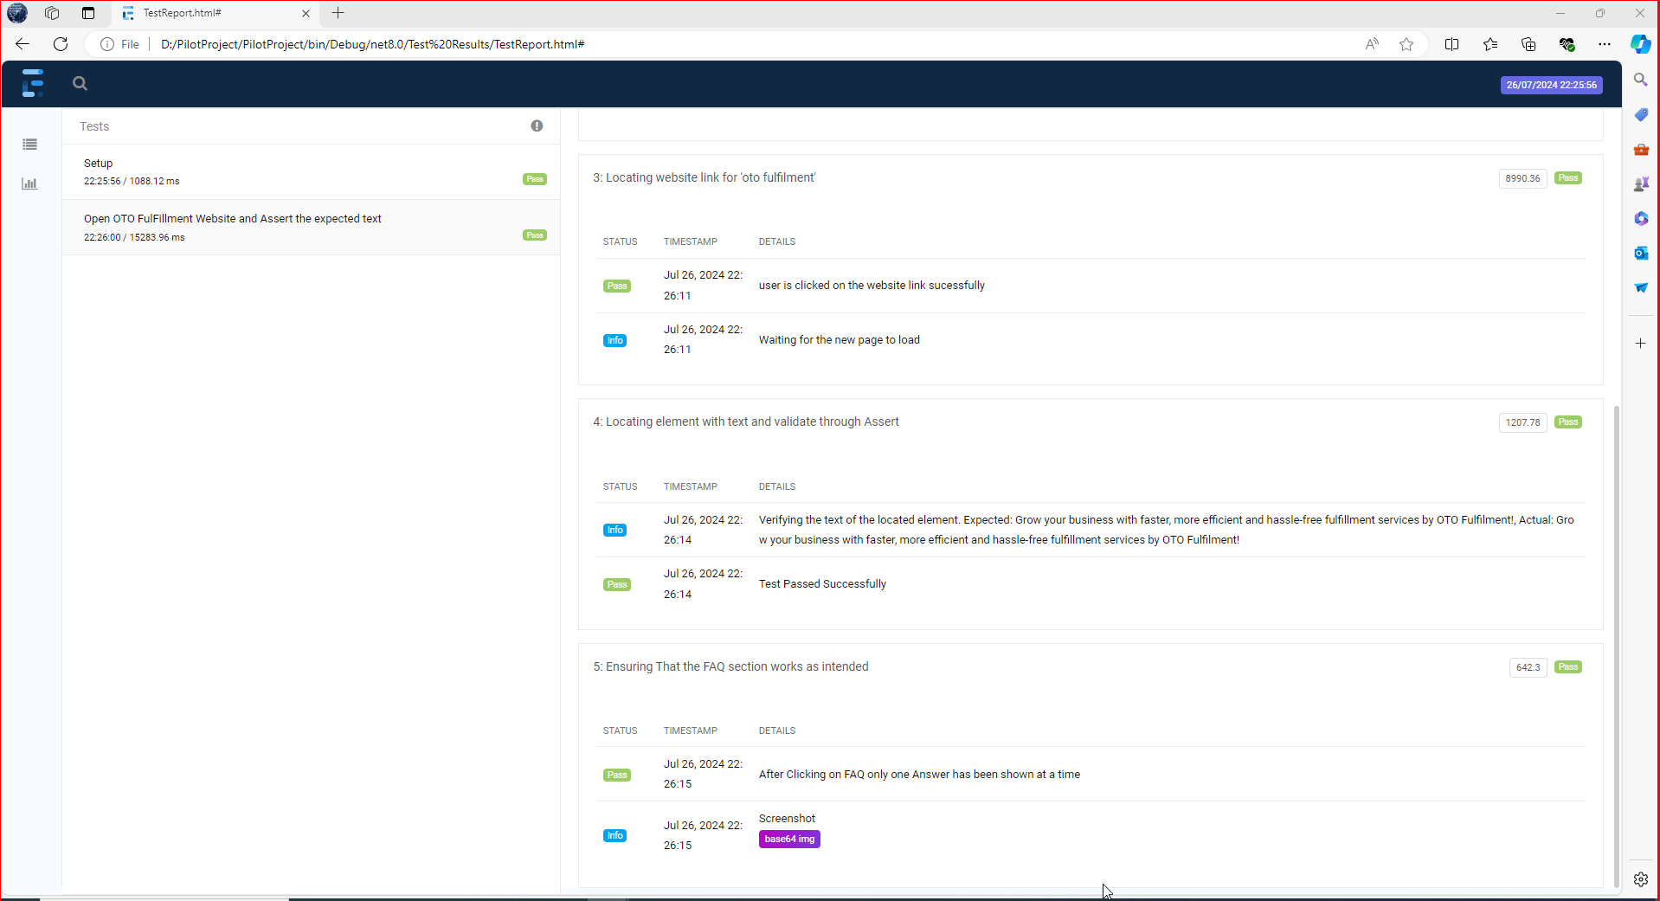

**Author**

Created by Saad Ali